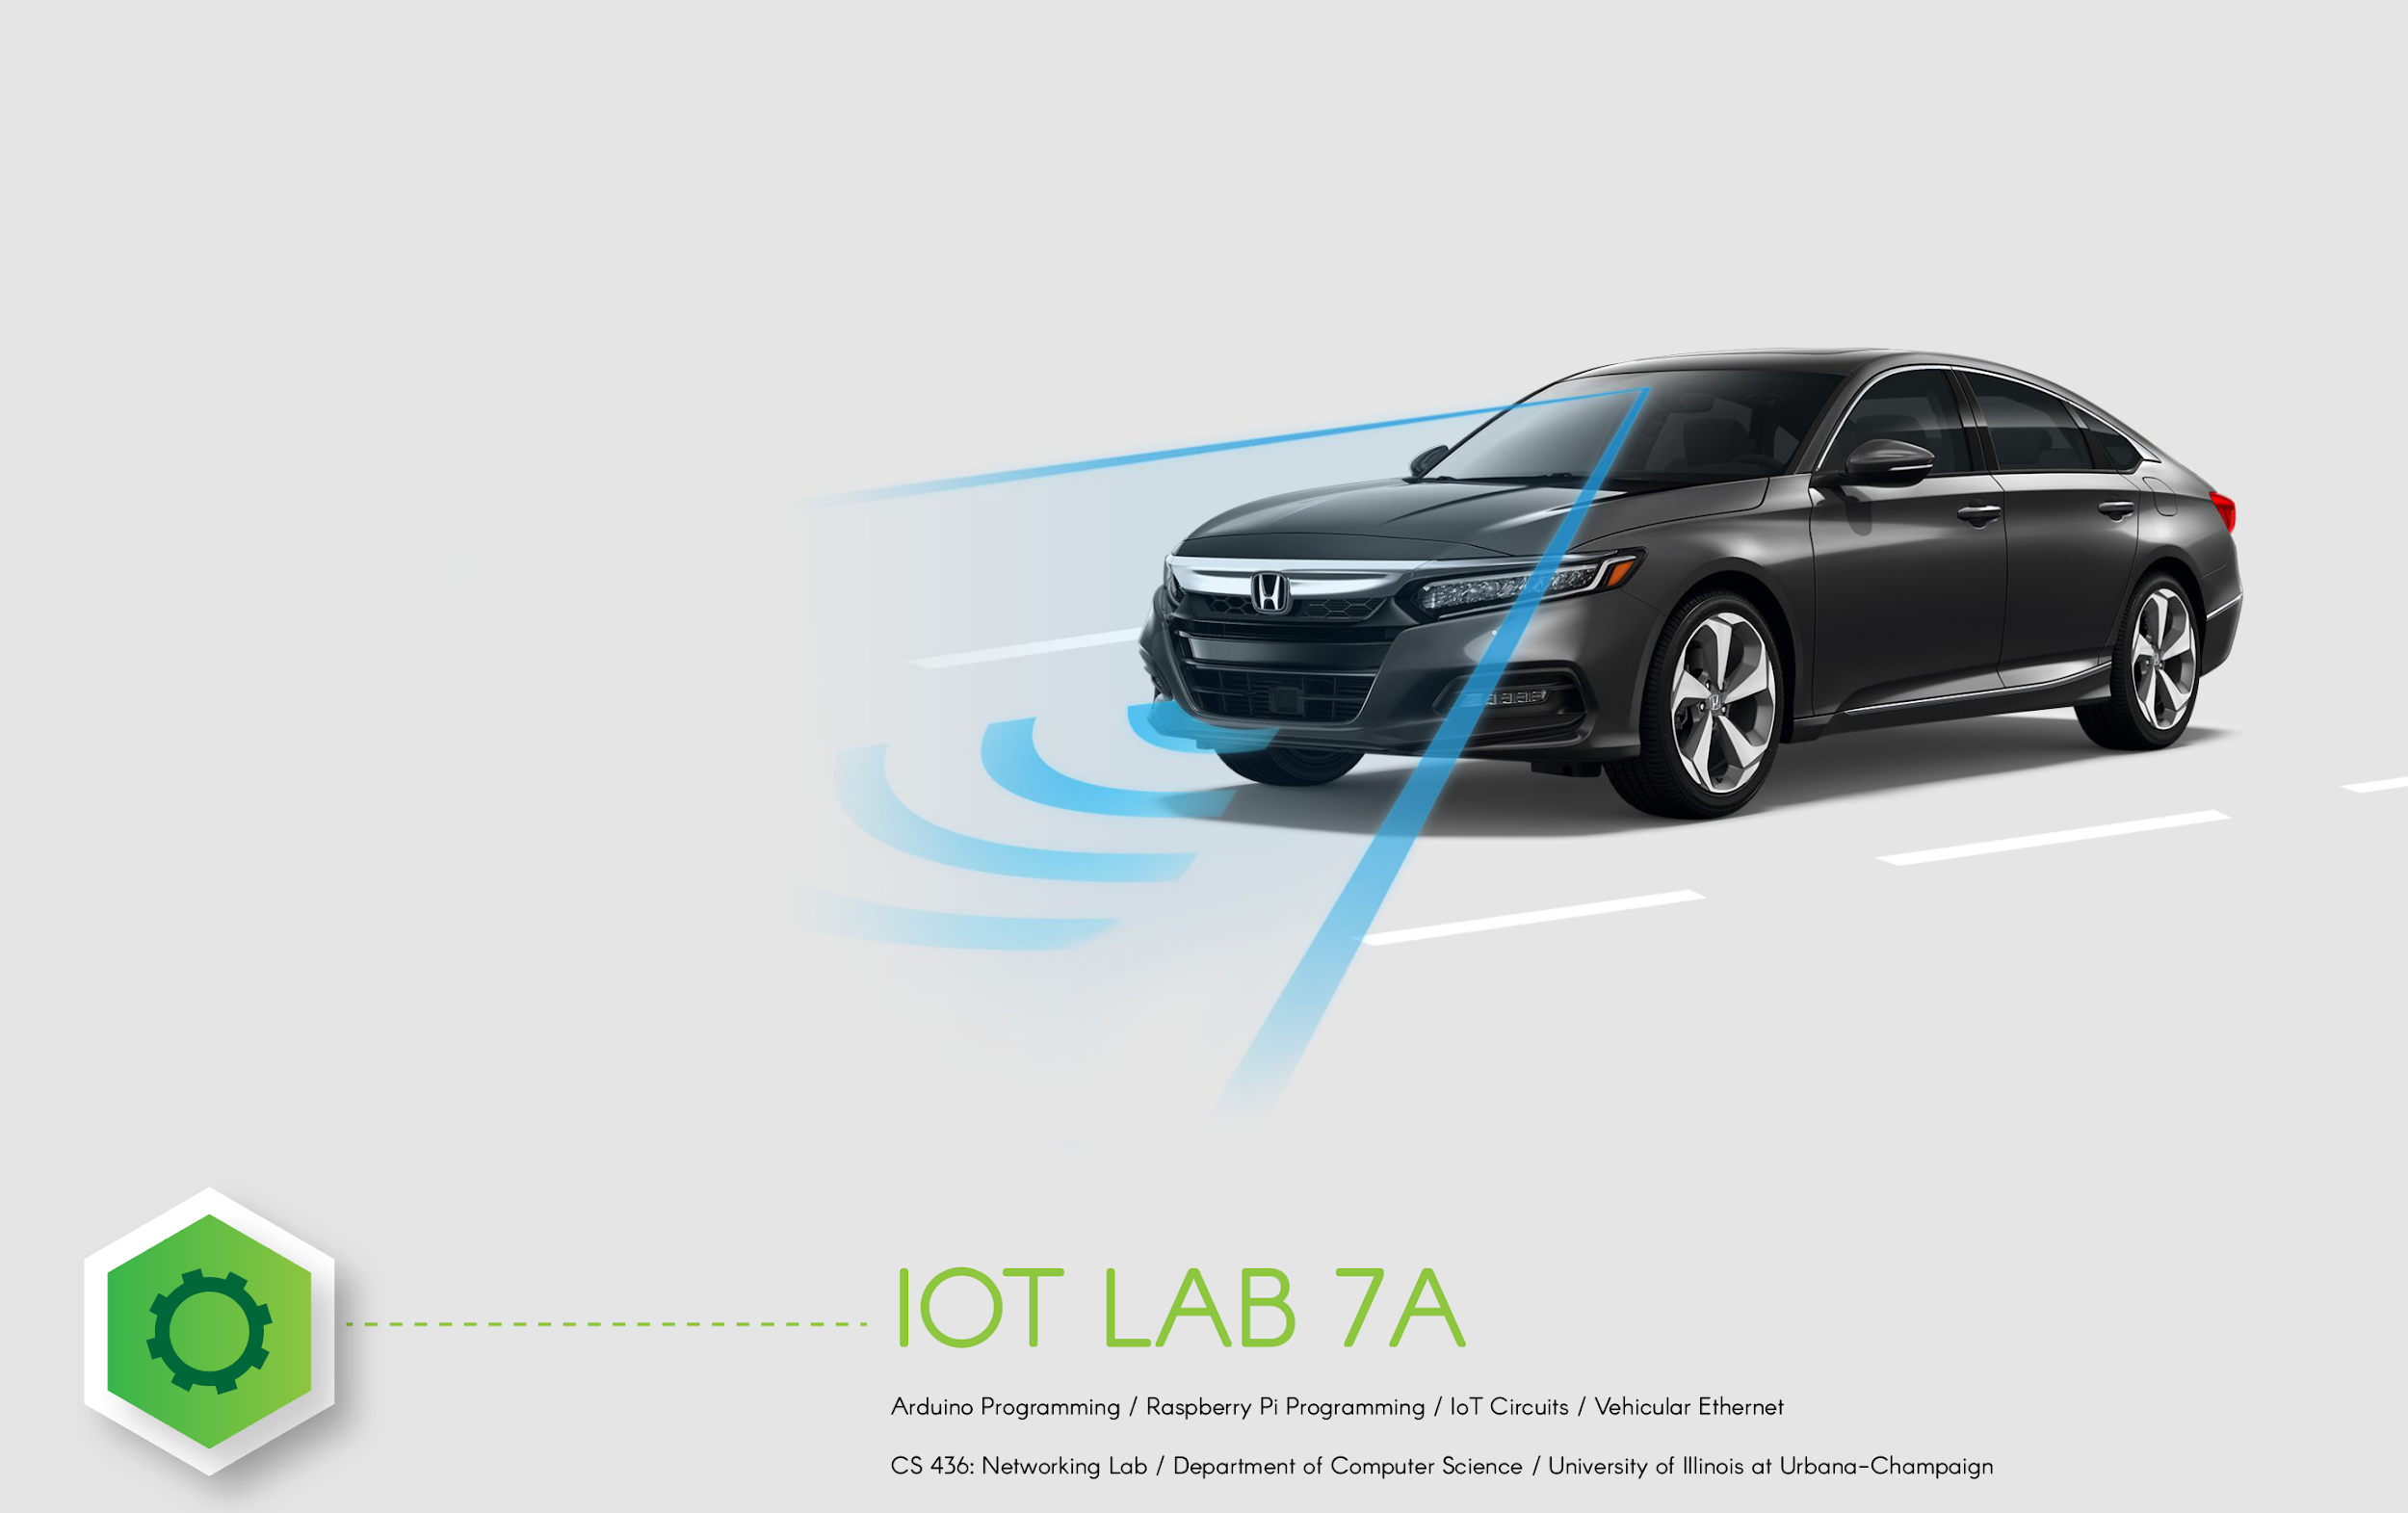**IOT Lab 1: IoT Devices**

***DISCLAIMER:*** *This lab looks long - do not worry! Most of this document is more like reading material than a lab. Our goal is to provide you with extensive descriptions, to walk you through each step, so you will not get stuck, and to also teach you additional things. It is ok to skip over parts of the reading if you feel comfortable and don't feel like you need the extra help.*

***We strongly encourage you to work in teams****, even if the team project requirement does not apply to you.*

# **Lab Overview**

Modern cars are no longer just engines and tires. Inside of them are highly sophisticated computer networks, controlling and monitoring an array of sensors, machine learning and computer vision algorithms, performing mathematical computations to keep you and your passengers maximally safe in every contingency and danger that arises.

In this class, we will guide you to gain experience with Internet of Things devices. You will do this by implementing a 2021 Tesla Model S. In particular, you will be implementing a vehicular network, navigation systems, and computer vision infrastructure comparable to a simplified version of the 2021 Tesla Model S. To save on costs, we won't be building a life-sized car, we'll build something smaller (and simpler!). But don't be fooled though - your infrastructure will share several key capabilities with real car platforms, performing real-time communications within the automobile to perform life-saving features such as obstacle avoidance and lane departure mitigation. Doing this will give you experience in programming IoT components, as well as teach you about vehicular networks, an emerging powerful use case for IoT.

For many of you, this will be your first experience working with real hardware. This may make this lab assignment different from other labs/homeworks you've worked on in the past. A few things to keep in mind (a) try to purchase the hardware components as soon as possible - they may take some time to ship (b) if you encounter a problem, try googling for it or post in the forums - some solutions are already online. Your efforts will be rewarded at the end of the lab with a confidence that you can build real things.

# **What to Purchase**

In order to complete this lab, you will need to purchase some things. Working with real components and assembling them yourself is both important and necessary to give you a more complete, hands-on experience. Since you purchase these components yourself, they are yours to keep, and the thing we construct will be something that you can keep and continue to use (show your friends!). Moreover, many of these components are general-purpose widely used to build IoT devices - if you like, you can later reassemble them into many other amazing IoT projects.

Here is what you will need to purchase for this project. We suggest you purchase exactly these items where possible - variants of these components will probably work but there is some chance you may end up with something incompatible so to keep things simple, if you don't know what you're doing, just try to purchase exactly what we have on this list.

**What you need to order:**

**[WARNING - some prices of these items have increased substantially due to the pandemic and chip shortages. I encourage you to shop around, consider using Google Shopping, Amazon, Walmart, etc., to try to find the lowest possible prices in your region.]**

1. **Raspberry Pi[1] 4B (4 GB RAM) (**[**Link**](https://www.amazon.com/Raspberry-Model-2019-Quad-Bluetooth/dp/B07TC2BK1X/)**) (**[**Alternative Link**](https://www.raspberrypi.org/products/raspberry-pi-4-model-b/?resellerType=home&variant=raspberry-pi-4-model-b-4gb) **- select 4GB or 8GB) (**[**Alternative Link**](https://www.amazon.com/CanaKit-Raspberry-4GB-Starter-Kit/dp/B07V5JTMV9/) **- full kit with additional items):** A Raspberry Pi is like a small computer. We will be using it to run various programs to control the car.
2. **64 GB microSD (**[**Link**](https://www.amazon.com/Samsung-MicroSD-Adapter-MB-ME64GA-AM/dp/B06XX29S9Q/)**):** ([32 GB](https://www.amazon.com/Samsung-MicroSDHC-Adapter-MB-ME32GA-AM/dp/B06XWN9Q99/ref=pd_bxgy_2/130-8043551-8939619?_encoding=UTF8&pd_rd_i=B06XWN9Q99&pd_rd_r=9dd783b5-85f6-4f70-a80b-771787b8d15e&pd_rd_w=rUO2E&pd_rd_wg=piXm5&pf_rd_p=ce6c479b-ef53-49a6-845b-bbbf35c28dd3&pf_rd_r=F6TQ7A0J6N4QD70DT26Q&psc=1&refRID=F6TQ7A0J6N4QD70DT26Q) should also be fine) You'll need to load data on that card using your PC - you might need to purchase an SD/microSD Card Reader if your PC doesn’t already support it. (Something like [this](https://www.amazon.com/SmartQ-C307-tarjetas-port%C3%A1til-individual/dp/B06ZYXR7DL/ref=sr_1_3?crid=CXV4X921BA7X&dchild=1&keywords=sd+card+reader&qid=1597945942&sprefix=sd+card+reeader%2Caps%2C166&sr=8-3))
3. **Raspberry Pi Camera:** This camera will be used to give your car the gift of vision! Your camera will be able to see and recognize objects in its environment. <https://www.amazon.com/Raspberry-Pi-Camera-Module-Megapixel/dp/B01ER2SKFS/>
4. **Car Chassis Kit (**[**Link**](https://www.amazon.com/dp/B087QKRX5J/)**) (**[**Alternative link 1**](https://www.sunfounder.com/collections/new-products/products/raspberry-pi-car-robot-kit-4wd)**) [2]:** This will be the physical housing of the car, including the wheels, steering mechanism, and rest of the chassis.
   1. If you would like to do something different, you can complete this lab using an alternative kit, for example a robot dog ([link](https://smile.amazon.com/Freenove-Raspberry-Balancing-Recognition-Ultrasonic/dp/B08C254F73/)), spider ([link](https://www.amazon.com/Adeept-Quadruped-Raspberry-Crawling-Self-stabilizing/dp/B07TLK5GP8/)), tank ([link](https://www.amazon.com/Adeept-RaspTank-Wireless-Raspberry-Transmission/dp/B07Q3RQCQS/)) - however, note not all kits are compatible with this lab, so you're on your own if you choose one of these.
   2. We would like to also let you know that students have successfully done this lab with these cars as well: ([Link 1](https://smile.amazon.com/Freenove-Raspberry-Tracking-Avoidance-Ultrasonic/dp/B07YD2LT9D/)) ([Link 2](https://www.amazon.com/dp/B06XWSVLL8/ref=cm_sw_r_cp_api_glc_fabc_WmFcGbZCFMF77?_encoding=UTF8&psc=1) - this one also works but you'll have to manually mount the sensor atop the camera, which can be a bit of a pain)
5. **18650 Batteries (**[**Link**](https://www.amazon.com/Rechargeable-Flashlight-18650-Batteries-Charger/dp/B089R8JZ78/)**) (Alternative links** [**1**](https://smile.amazon.com/Tactical-Flashlight-Rechargeable-Batteries-Resistant/dp/B07SQLRMQH/) [**2**](https://smile.amazon.com/Rechargeable-Headlamp-Flashlight-Batteries-Outdoors/dp/B07ZXZQMRS/)[**3**](https://liionwholesale.com/products/protected-2600mah-10a-18650-button-top-battery-wholesale-discount?_pos=3&_sid=4737a14ef&_ss=r&variant=28408793923678)[**4**](https://www.illumn.com/batteries-chargers-and-powerpax-carriers/batteries/18650-samsung-inr18650-25r-r5-2500mah-green-high-discharge-flat-top.html)[**5**](https://www.18650batterystore.com/products/samsung-30q-protected-pcb)[**6**](https://www.imrbatteries.com/)[**7**](https://liionwholesale.com/)[**8**](https://www.walmart.com/ip/Hyper-Tough-Lithium-ion-18650-Replacement-Battery-2-Pack/959057722)**):** These batteries will be used to provide power to the car and Raspberry Pi. A 4-pack of 18650 batteries should be sufficient if you can find other links. Make sure you get a set with a charger (or if you get something like [these](https://www.18650batterystore.com/products/samsung-30q-protected-pcb)  that don't come with a charger make sure you get the [charger](https://www.18650batterystore.com/collections/18650-battery-charger/products/nitecore-i4)  ([Alternative link](https://www.amazon.com/gp/product/B01N4NS31O/)) separately as well).
6. **Optional items:**
   1. **USB Type-C cable and charger (**[**Link**](https://smile.amazon.com/Raspberry-Model-Official-SC0218-Accessory/dp/B07Z8P61DQ/)**)**: This is useful to power the Pi instead of using the batteries while the device is stationary (Warning: DO NOT run the motors when solely powered by the cable as the Pi can not handle the amount of current which can cause it to burn out). If you happen to have a powerful enough charger already you can just get a USB-C cable **(**[**Link**](https://www.amazon.com/AmazonBasics-Type-C-USB-Male-Cable/dp/B01GGKYN0A/ref=asc_df_B01GGKYN0A/?tag=hyprod-20&linkCode=df0&hvadid=167140037427&hvpos=&hvnetw=g&hvrand=3540782772009889637&hvpone=&hvptwo=&hvqmt=&hvdev=c&hvdvcmdl=&hvlocint=&hvlocphy=9028275&hvtargid=pla-299278414041&psc=1)).
   2. **An external computer monitor:** An external monitor to plug into the Raspberry Pi isn't required but will make some steps of this lab easier. Any computer monitor you have lying around will do, but you can also buy something specifically designed for the Pi such as ([Link](https://www.amazon.com/Lebula-Touchscreen-Raspberry-1024X600-Capacitive/dp/B07VNX4ZWY/ref=psdc_1292115011_t1_B07S51QDTG)).
   3. **Video display cable:** Note the Raspberry Pi 4 has MicroHDMI output, so you'll need a MicroHDMI to HDMI cable if you plan on using an HDMI monitor with your Pi ([Link](https://www.amazon.com/CanaKit-Raspberry-Micro-HDMI-Cable/dp/B07TTKD38N)).
      1. You can alternatively use a VNC (Virtual Network Computing) server to stream the Pi’s GUI to a remote machine. Use this [link](https://www.raspberrypi.org/documentation/remote-access/vnc/) to set up VNC. There are also other alternatives like [VSCode](https://code.visualstudio.com/docs/remote/ssh).
   4. **USB keyboard and mouse (**[**Link**](https://smile.amazon.com/Logitech-Desktop-Durable-Comfortable-keyboard/dp/B003NREDC8/)**):** Similarly, it can be helpful to have a USB keyboard and mouse to plug into the Raspberry Pi. If you already have a USB keyboard and mouse you can probably just use those.

# Background on Self-Driving Cars

To help provide some context for our work, and to teach you more about vehicular IoT in general, in this section, we give some background on autonomous vehicle design. We start out by giving a functional overview of the internals of an autonomous vehicle.

# 

***Figure 1: Overview of how intra-vehicular networks are built in real cars (you'll be building a simplified version of this in the next section -- keep reading). The parenthetical marks denote comparable IoT components that could be used to emulate the corresponding components (real cars don't use Raspberry Pis and such, but they do use microcontrollers/processors and such that provide similar functions).***

A typical vehicular network (shown above) consists of a Head Unit, an Ethernet Switch Unit (ESU), an Advanced Driver-Assistance System (ADAS), Engine Control Units (ECU), Sensors (Like Ultrasonic sensors and Lidars), an Ethernet Network and a CAN[3] (Controller Area Network). A CAN is a network within the car, providing a means of communication between the various sensors and microcontrollers in a distributed fashion without the need for a dedicated head computer. The Head Unit allows the vehicle to communicate with the Internet via 5G or Wi-Fi, while displaying media and driving assistance information to the driver. The ADAS is responsible for taking input from all the sensors to perform driver assistance like lane departure mitigation and obstacle avoidance. Although the recent trend of Vehicular Networks is to leverage Ethernet, most cars still have a CAN bus for inter ECU communications, as well as providing diagnostic information via the [OBDII](https://en.wikipedia.org/wiki/On-board_diagnostics) port[4].



***Figure 2: External on-board sensor deployment***

# Tasks You Will Perform In This Lab

Before implementing vehicular networks on a real car, an important step is prototyping. The common approach in the industry is to test with the intended workflow until we have enough confidence with the structure of the system, before starting to produce the hardware. Although a true vehicular network may contain more components in the architecture, for the purpose of this lab we will take a simplified approach, building one individual car prototype with a simplified degree of autonomy. The prototype will include the following sub-systems:

1. **An obstacle avoidance system leveraging proximity detection.** You will leverage the Raspberry Pi to receive distance data from a bumper-mounted ultrasonic distance sensor. You will develop a simple navigation algorithm that processes input from both the CNN models and the ultrasonic sensor to navigate to a pre-set destination while avoiding obstacles.



***Figure 3: What you will implement, system architecture view***

For simplicity, we'll skip some of the details in our implementation - the CAN bus, LIDAR, GPS, etc, but by going through the steps below you should get a sense of how these supplementary systems "plug in" to what you have.

**IOT Lab 1: IoT Devices (Part 1)**

**Due 2 weeks before part 2**

Ok, now let's get started! In part 1, you will assemble the car, explore the Pycar code, and implement some naive mapping and routing.

# Step **1: Chassis Assembly**

A key step when constructing an IoT device is putting together its housing and physical assembly. Oftentimes this will be the last step in your design process, after you have fully thought through about the structure of what you want to build, its environment, and so on. But in this case, since we know what we're building, we'll start with this step.

To put together the car housing (chassis), as well as setting up the Raspberry Pi to function with it[5], please follow the guide found [at this link](https://drive.google.com/file/d/1EPBqR5zZ24e2lzKgk8_uIlzh_wIRuezV/view?usp=sharing). (backup link: <https://m.media-amazon.com/images/I/C1Tq1JjfipS.pdf>)[6]. You may also find these youtube videos helpful:

<https://www.youtube.com/watch?v=7m1DLLG3A8s>

(10 min tutorial on assembling the Picar)

<https://www.youtube.com/watch?v=UiRb1SDpezY>

(2 min video showing (tracking line, objection detection, keyboard controls)

The link above will walk you through how to install the Raspberry Pi operating system on it, but if you could use some additional instructions you can follow these:

<https://www.raspberrypi.org/documentation/installation/installing-images/README.md>

After you have flashed the image, insert the card into Raspberry Pi, and connect a monitor, mouse and a keyboard to the Pi via the HDMI and USB ports. The Raspbian OS would automatically be installed once you start the Pi. Now you will have a fully functional Linux system on your Pi, with Internet access via the Wi-Fi module. Note you don't have to specifically use the optional power adapter mentioned early, any USB-C connection with enough amps will keep the Pi powered on (it will give you warnings or not power on if it's not getting enough power).

To assist you through this process, we'll walk you through in more detail the steps of setting up the Raspberry Pi next.

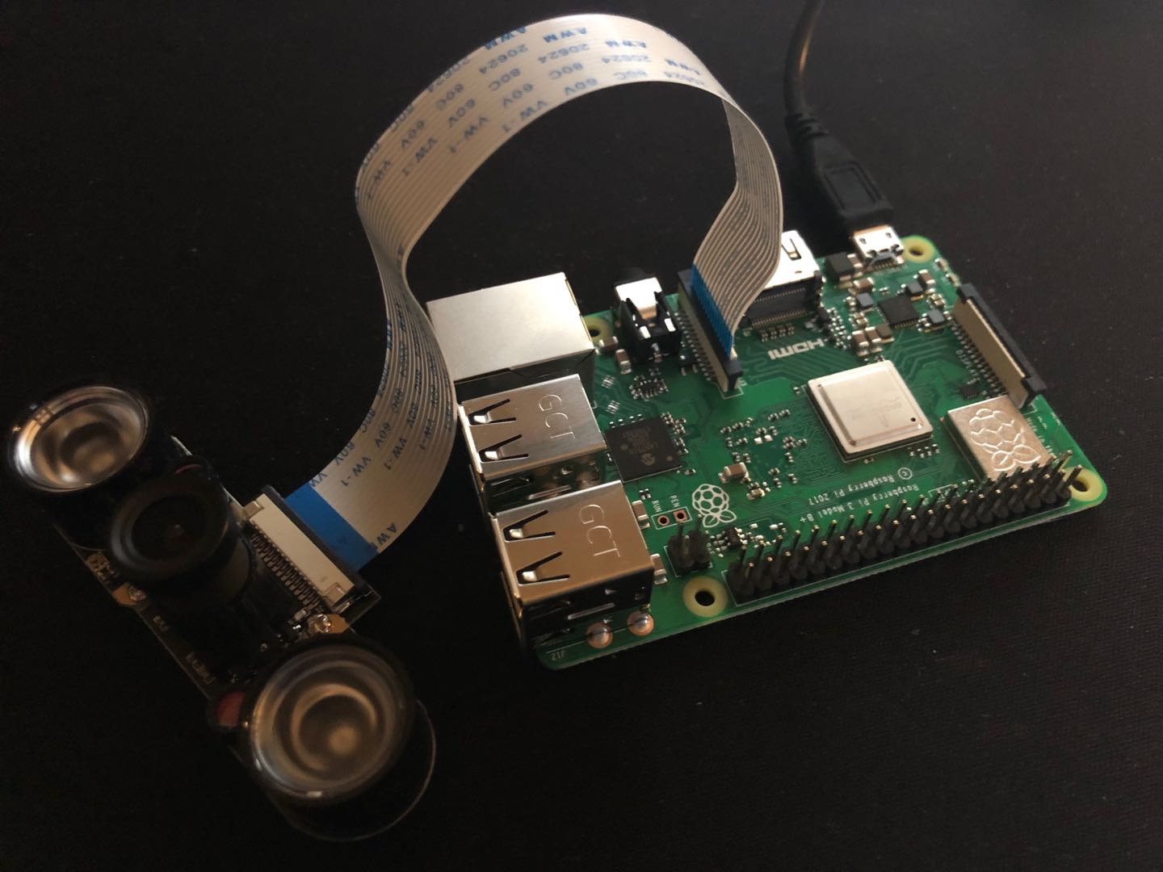

***Figure 5: Raspberry Pi with Camera installed.***

Do not underestimate a Raspberry Pi - It’s cheap (~$40), but it’s a powerful computer for its size! Equipped with a Linux Distro (Raspbian), an HDMI port for Monitors, USB ports for mice and keyboards, an SD card as a disk, a camera interface, Wifi and Ethernet module, and 40 GPIO pins, Raspberry Pi allows you to quickly prototype your IoT network without much hassle. When you have set up the Raspberry Pi, you will have a fully functional Linux system on your Pi, with Internet access via the Wi-Fi module. We will be using it to control the car in various ways, but please keep it forever, as it can do so many amazing things beyond just what is described in this lab!

Helpful hints:

1. If you use a 64 GB microSD (or larger), please follow the instructions in [this link](https://www.raspberrypi.org/documentation/installation/sdxc_formatting.md) to format the microSD with FAT32, instead of the step 2 in page 9 in the above guide. This is necessary because the SD Formatter will use exFAT which is not supported by the Raspberry bootloader.

2. The Raspberry Pi 4 has an HDMI port that you can use to connect it to a monitor if you have one[7]. If you do not, Pages 20-21 of the above guide tells you how to install the Pi up in "headless" mode. Those instructions are ok, but here are easier ones:

1. First, download the imager from <https://www.raspberrypi.org/downloads/>
2. Then, run the imager. Follow the steps it provides to put the recommended OS onto your SD card.
3. The SD card should now have the OS - add an empty ssh file to the root of the SD card to enable ssh access.
4. Add a wpa_supplicant.conf file to the root[8] of the SD card using the following instructions: <https://www.raspberrypi.org/documentation/configuration/wireless/wireless-cli.md> . Change the country code from US to your 2-letter ISO 3166-1 country code if not in the USA. Also change the ssid (name of your Wifi network - note this is case sensitive) and psk (your Wifi password) Sample file:

| ctrl_interface=DIR=/var/run/wpa_supplicant GROUP=netdev  update_config=1  country=US  network={  ssid="WiFiName"  psk="WiFiPassword"  id_str="school"  priority=0  } |
| --- |

For our purposes, we will need to use a camera module, which is not part of the instructions in the link above. Formal mounting of the camera should not be necessary; folding the camera to face straight forward and applying tape would be sufficient. If you would like something a bit more solid, you can cut a slit on top of the PiCar and mount the camera through that slit[9]. To ensure you have the camera mounted and oriented properly, please load a picture on your cell phone's screen, and hold it in front of the car where you think objects might reasonably appear when the car is driving around. Then, look at the frame of the camera and place a picture on your phone within the frame of the camera and see if your car detects it and reacts as expected, i.e. stopping and waiting for the person to pass. If needed, adjust the camera placement on top of the car so the car can "see" the road nice and well.

Here are a few screenshots of the assembled car from a few different angles -- take a look and do some sanity checks to make sure you assembled it properly:

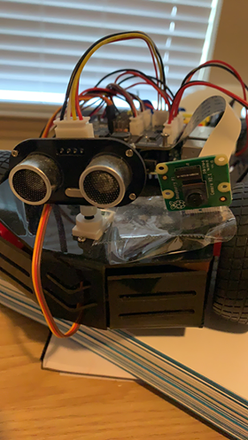 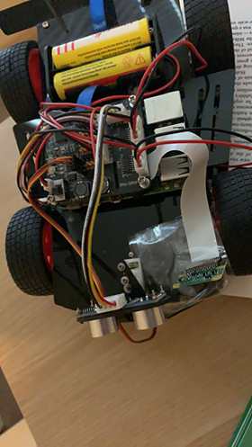

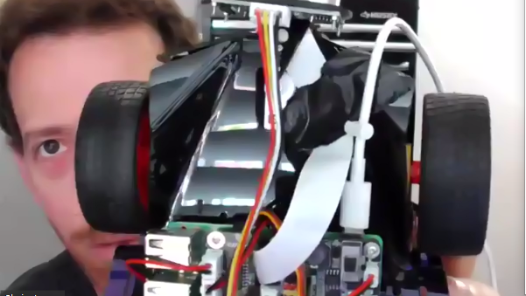

The Raspberry Pi should be set up first, but after that, the chassis assembly and the routing/mapping logic (we'll get to these in later sections) can be done in parallel. Note that the picar-4wd library code includes functions and example scripts; use them as you see fit, and feel free to fiddle with the car’s config file for car motion.

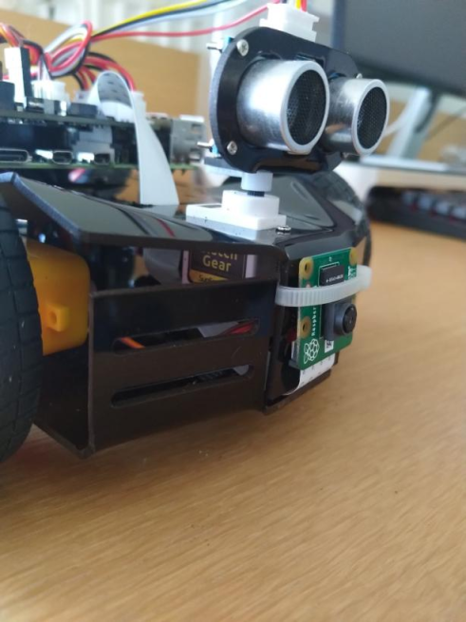

***Figure 4: Mounting the ultrasonic sensor atop your smart car.***

There are example scripts at the bottom of the setup pdf (keyboard_control.py, servo, etc) that can be run to ensure you’re assembling the chassis properly.

# Step 2: Explore the Pycar Code

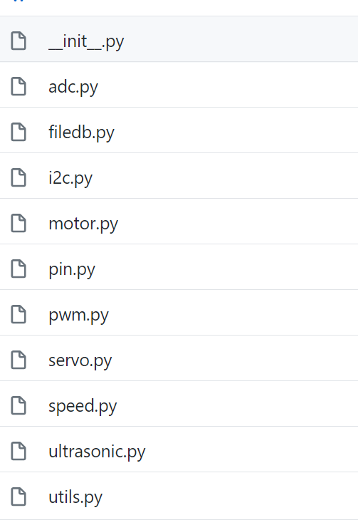

***Figure 5: Example code provided with the Pycar library . Look through it and get a sense of what it does!***

Now that you have built your car, it’s time to test it out and get familiar with the PiCar library (which can be downloaded [here](https://github.com/sunfounder/picar-4wd) ). Before we get into too much programming, we think it will be helpful for you to kind of look over the code and get a sense of what it does and how it works.

The first step will be to download the code[10]. Make a copy of it on your Raspberry Pi and read over the documentation and codebase. You don't need to read everything, just skim over parts and get a sense of how things work. In particular, look under the doc folder with all the markdowns of each function and its descriptions. We encourage you to also write your own sample script and try calling some of these functions, i.e. reading from the ultrasonic or making the motors spin. Play around with the functions and try making the car do different things.

Another helpful part of the codebase we strongly encourage you to read and run, to both verify that your assembly is correct and to get you comfortable with the library, are the examples. The various examples should thoroughly test the functionalities of the car and provide you with some reference when writing your own control script.

First, try running the keyboard_control.py program and making sure it works. This is important since it tests all your motors are running in the right direction; if that is not the case, you could either take apart the car and move around the motors (a rather arduous process) or adjust the directions of the motors in the data/config file. We recommend you also walk through the code and make sure you understand the function calls being made in this script, and see if you can trace the function calls back up inside the code as far as you can, since the library offers us wrappers to manipulate the components. For example, when you call fc.forward, that actually leads to the actual outputs in the motors’ corresponding GPIO pins to be changed -- see if you can look through the code and understand how that happens.

The next script you should explore is ultrasonic.py, which is the script responsible for interfacing with the car’s ultrasonic sensor for distance measurements. More information on the ultrasonic module for the Raspberry Pi can be found [here](https://tutorials-raspberrypi.com/raspberry-pi-ultrasonic-sensor-hc-sr04/), but essentially what it does is send out a small pulse of sound and measure the time it takes for that sound to bounce off the object in front of it and return (similar to what bats do), and then uses that time and the speed of the sound to calculate distance. A lot of this is abstracted away for you, but it’s still good to know how it works. Look through the ultrasonic.py file and trace back the function calls as far as possible, and get familiar with measuring distance since you will need it in the mapping portion of your script.

The third component worth exploring is the servo, which is what the ultrasonic sensor is mounted on. The servo is a type of motor that allows you to precisely control its rotation, which makes it the perfect option for us to rotate our ultrasonic sensor when taking distance measurements. servo.py contains all the wrapper code for interfacing with the servo motor and setting the angles, but again, please trace the function calls and see how the actual component is manipulated. Experiment with these different scripts to get familiar with making the right function calls.

Once you have some comfort with the PiCar library and the abstractions it provides, you can begin writing your scripts! Some good first steps, to see how these different functions can fit together: try having your car go forward by a certain distance, or have your car drive forward until it detects an object within 10 cm of it, or perhaps even try having your car go in a circle. As an example, here is some code that, when called, moves the car backward (or forward, depending on how your motors are configured) by a constant amount. Your results may vary depending on the surface on which this movement is being tested.exactly 2.5 cm.

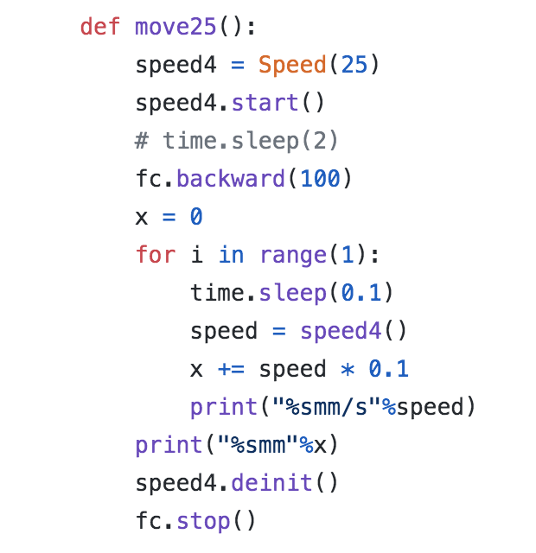**.**

***Figure 7: Example code to move the car using the picar-4wd library***

These are just some example ideas that you can try to get comfortable with the library. When you feel ready, proceed to the next section to get started writing a script to make your car autonomous!

# Step 3: Environment Scanning (Mapping)

As an autonomous car drives, it must be aware of its environment. You'd think it could just follow GPS, but driving is much more complex than just knowing what roads to follow. There are other cars on the road, there will be obstacles such as road construction, pedestrians will step out in front, etc. Your car needs to be aware of its microenvironment to perform operations such as crash avoidance, summon[11], etc.

Luckily, the problem of automatically discovering a physical environment is one that has been long studied in the field of robotics. The field of *robotic mapping* has its roots in cartography and computer vision - there are a wide variety of algorithms that have been proposed, many of which typically involve a scanning process where the device "looks around" in some fashion, then internally constructs some sort of data structure representation of its environment that is amenable to processing (for later navigation and planning steps).

Real world self-driving cars use similar approaches, leveraging arrays of sensors mounted in various locations on the car, but join this information together with vast amounts of mapping data collected by GPS/fleets of other cars. This is what they use for high level navigation and routing from point A to point B. They also have object detection systems that are pre-trained to detect humans, other cars, stop signs, etc.

Since GPS is not granular enough to support true autonomy; cars make use of probabilistic SLAM (simultaneous localization and mapping) algorithms constantly being fed sensor data, they can pinpoint where they are relative to the map in real-time, and stitch together a thorough map built off pre-existing data and real-time data. SLAM algorithms aim to answer the question “what is the probability of the current map state (described by the locations of the obstacles and the agent) given the current set of sensor observations”. The process of mapping involves computing the probability of each position being occupied whereas localization involves finding the agent’s own frame of reference.

For the purposes of this lab we'll keep things much simpler though. What you will do is write a mapping algorithm that simply keeps your car from crashing into things. Your car will act much like a Roomba - it will approach objects, but before crashing into them, back up and traverse in another direction.

**What you need to do:** Write a program that uses the ultrasonic sensor to detect obstacles that come within several centimeters of your car's front bumper. When your car gets within that obstacle, it should stop, choose another random direction, back up and turn, and then move forward in the new direction.

Where you place your ultrasonic sensor can make a difference[12], especially if you're interested in exploring more advanced mapping algorithms -- if you're having trouble getting good readings (eg you see noise in them), try to remove possible sources of interference - try putting the car on a different surface (e.g., different kind of floor), take it inside if you're outside, etc. You can also make little blinders that direct the line of vision directly forward, like this:

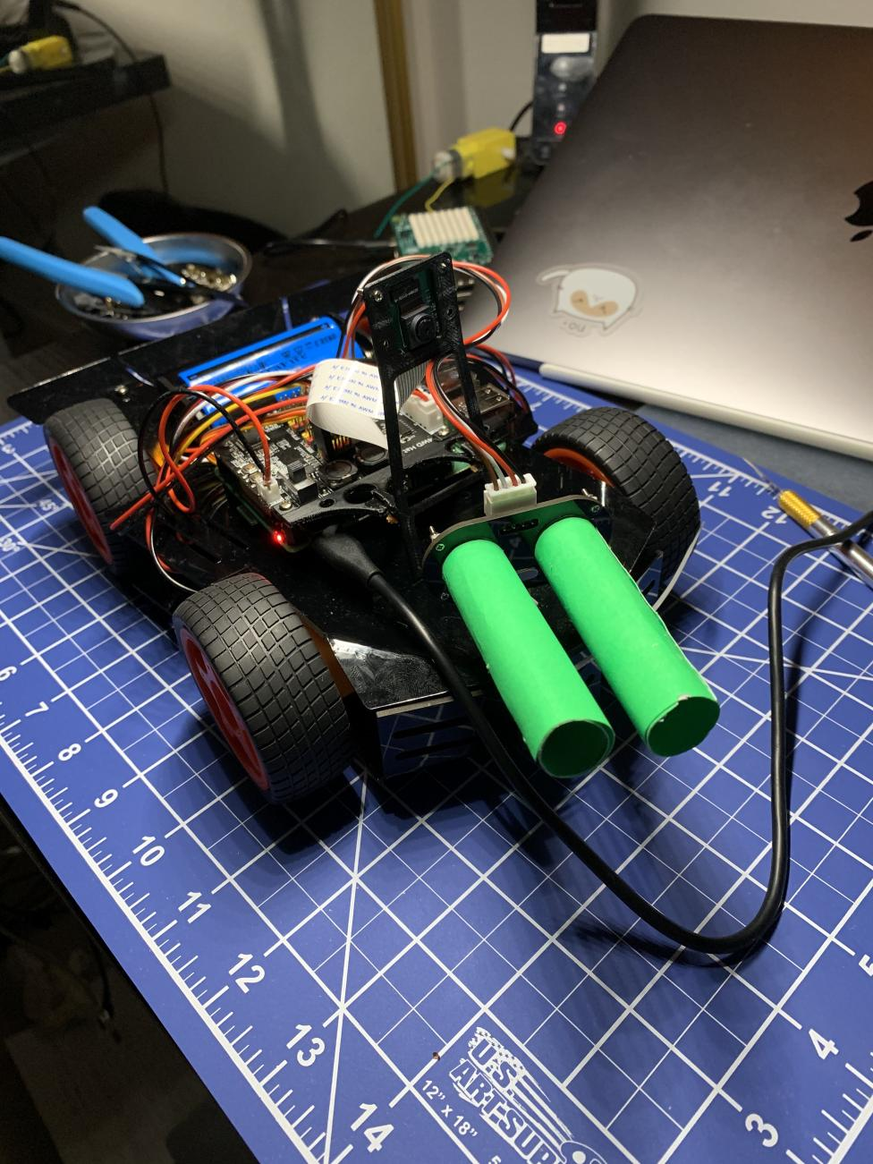

***Figure 6: Optional "Blinders" installed on ultrasonic sensor to improve proximity readings (could use dime rolls, rolled up pieces of paper, or 3D printed materials). You don't really need to do this but you can if you want to get extra precision in your readings.***

# Step 4: Driving

Next, we need to figure out if your car works. One idea would be to take it out on city streets. Put that sucker down in the middle of the road in front of your house and tell it to drive to the grocery store. This would clearly not be a good idea because your car is much smaller than other cars and it would get run over and broken by them[13].

Hence, in this part, you will be setting up a small obstacle course indoors. Pick a room in your house and set up a pretend environment for your car. We suggest something along these lines:



***Figure 8: Example environmental setup you can use to test your car.***

As part of your obstacle course, we need to test out the avoidance system you developed: Is your car able to recognize objects it should avoid? Is it able to do that accurately? Are there false positives (where it sees objects that do not exist) or false negatives (where it misses objects that are there)? Is your car able to route around objects? Is it able to do so correctly, leaving sufficient clearance around them? Is it able to do so quickly enough, to avoid a crash?

For the routing, the car should go around objects that are obstructing its path. In particular, the distance sensor should be used to recognize that an obstacle is in the way, and halt your car and drive around the obstacle. For an added challenge, try moving your objects around -- routing around the dynamic objects is risky[14] as the objects' movement is far more unpredictable than a fixed obstacle, so we use the distance sensor to act as an override for our routing.

# Part 1 Submission and Grading

To submit your own work, you will create a **demo video** (under 5 mins). The video should be hosted privately on cloud, with access permission given to the course staff. **Do not upload the video to coursera**. The demo video should contain:

1. 4 main points in the rubric.
2. The code you wrote as well as a walk through

Your final submission should be a **report** using [this template](https://docs.google.com/document/d/1lGtQSX4SZKkGaBdDjZhQZ57q6MEkR6HWmGziBy0zixg/edit?usp=sharing)in PDF format**.** The report must contain:

1. The link for the demo video
2. A topology specifying the wiring of all your devices. (We recommend drawing the graph using [Fritzing](http://fritzing.org/download/) ([mirror](https://drive.google.com/file/d/1OcdSiroMfAKlM5QUd16NUFiSiALOJrNX/view?usp=sharing)) to show detailed wirings, including the choice of pins on the Pi.)
3. Your design considerations for each step of the lab

The rubric for grading that you should follow is provided here:

| **Demo Video (50 pts)** | |
| --- | --- |
| **Is the car fully assembled? (10 pts)** | |
| The hardware connection is shown and discussed, and the components can power on | 10 |
| Things generally seem plugged in but there are clearly a few things not plugged in right or things seem incomplete | 5 |
| **Can the car move by itself? (10 pts)** | |
| The motors turn the wheels, can the car move under its own power, all without human involvement | 10 |
| Movement seems substantially broken in some fashion, e.g., the car attempts to move but the movement is severely hampered, or not all four wheels are turning, or the car is unable to move in a straight line, or if movement requires manual intervention to work | 6 |
| Movement does not work at all but students show the car should be able to move by showing their code, and the code seems right | 3 |
| **Can the car "see" (10 pts)** | |
| The car is clearly able to perceive its environment. It stops when it reaches an obstacle, or otherwise provides some evidence of reaction from sensing its outside world via its ultrasonic sensors. | 10 |
| Sensing works but is significantly broken, e.g., it only works sometimes or requires manual intervention for sensing to happen. | 6 |
| Sensing does not seem to work at all, but students show the car should be able to sense its environment, by showing their code, and their code seems right. | 3 |
| **Can the car "navigate"? (10 pts)** | |
| Upon encountering an obstacle, the car can navigate around the obstacle in some fashion, for example by backing up and going in a different direction (it is ok if students did something more fancy here, but in general, the car should avoid obstacles in some fashion). | 10 |
| The car is doing some form of navigation but incomplete, e.g., it crashes into objects or scrapes them, doesn't stop quickly enough | 6 |
| Navigation doesn't seem to work at all, but students show correct code and pin-point possible issues | 3 |
| **Code Walkthrough** (10 pts) | |
| Students clearly show and explain the code they wrote | 10 |
| Students explain the code without showing, or show the code without explaining, or show and explain only part of the code | 0-5 |
| **Report (35 pts)** | |
| **Topology (10 pts)** | |
| Hardware topology contains all the components and clearly shows how they are connected | 10 |
| Topology has missing component (-2 pts for each) or the connections are unintelligible | 0-8 |
| **Report Comprehensiveness (20 pts)** | |
| Report contains detailed information about the students' thought process, such as how they approach the problem, how they reach their final implementation, the challenges they faced, etc. | 20 |
| Report is not comprehensive enough | 0-19 |
| **Submission Format (5 pts)** | |
| Report is submitted in PDF format, video is hosted privately on cloud with access permission granted and does not exceed the 5 minutes limit. | 5 |

| **Category** | **Points** |
| --- | --- |
| Video | 40 |
| Report | 20 |
| Submission Format | 5 |
| **Total** | **65** |

# Where to Go From Here

In this lab, you gained familiarity and comfort with doing basic IoT engineering. You learned how to work with Raspberry Pi, one of the most common platforms for IoT development. You also learned how to use sensors and actuators to interact with the environment using simple robotics.

There is certainly more to IoT than this, and I encourage you to continue your journey into the world of IoT, both in terms of gaining more extensive understanding of the concepts underlying these technologies as well as extending your breadth to other IoT technologies, which we will do in later labs (in fact, the next two labs will build upon your car to give it powerful new capabilities - we will develop networking leveraging bluetooth/wifi, as well as develop a cloud backend with machine learning). That said, the experiences you gained in this lab are general, and with them, you should now be able to attempt things like:

* Create an automatic cat feeder that dispenses food whenever it sees your cat (OpenCV already has cat detection algorithms, and you can find various sorts of motors/housings on websites like adafruit.com).
* Create an intelligent manufacturing safety system to turn off assembly machines when human yells are detected (look around at your workplace: many lighting/security/HVAC systems, robotics, electrical distribution systems, even the car you drive, are able to be monitored and controlled by interfaces where you simply adjust voltages on input wires).
* Continuously monitor health of an ill family member or friend and leverage machine learning to find problems early (regulation slows technology adoption in healthcare - many open-source projects are leveraging increasingly cheap medical sensors to do things far beyond what hospitals can do on their own).

**IOT Lab 1: IoT Devices (Part 2)**

In part one of this lab you constructed a basic self-driving car. Currently your car acts kind of like a Roomba - it goes until it encounters an obstacle, then backs up and tries another path, etc. In this lab, you will give the gift of computer vision to your car. It will be able to understand what obstacles are in front of it, and much more. To do this, we will have to build a more advanced understanding of computer intelligence, which we will do through the following steps.

# Step 5: More Advanced Mapping

The simple driving algorithm above was a good start -- it was sufficient to give you a neat self-driving car toy and gives you a flavor of how to design navigation. However, we want to mention that in practice navigation can be much more advanced.

In the real world, intelligent systems will typically construct a formal representation of their physical environment to assist in their navigation capabilities. Self-driving cars for example will construct a "map" of the environment that consists of a scanned 3-dimensional point representation observed from various sensors on the car, annotated with semantics (e.g., "this part over here is a stop sign, this part over here is a person"). To provide more advanced navigational capabilities to our car, we will start by implementing a more advanced mapping algorithm -- to keep things simple, we'll work in two dimensions, though what you learn generalizes directly to higher dimensional analysis.

You will be implementing a more general non-probabilistic mapping model, with localization being emulated by incrementing our position based on velocity readings. In particular, our car must use data from the ultrasonic sensor and potentially the camera to detect obstacles around it as well as their distances. To do this, you can[15] create a numpy array map data structure in your python code, where you store the data as a numpy array of 0’s and 1’s, where a 1 represents there is an obstacle within a certain threshold distance, and a 0 indicates there is not[16], and the array index indicates the angle (from the car's perspective).

One way to perform the mapping is to scan the surroundings by reading distances from the ultrasonic sensor every few degrees, and interpolating distances in between those points as well to generate a rough map of the surroundings. For example, if you find the distance to the nearest object at 60 degrees on the servo to be 20 cm and the distance at 55 degrees to be 20 cm as well, you can consider those as two points on a coordinate grid, calculate the slope between them, and fill in all points between them that lie on that line as being “objects” in your internal map. In our internal map, we can set positions that are open (no object) as 0, and positions that contain objects as 1. Imagine a 100x100 numpy array where each element represents a 1x1 cm grid. If your car is at (0,0)[17] and you find the distance reading on the ultrasonic sensor at 0 degrees shows 10 cm, we would mark (10, 0) as a 1, since that is where we find our first object. Variants of SLAM (Simultaneous localization and mapping) algorithms can also be used for this step[18].

# Step 6: Object Detection

In this step, you will learn how to work with computer vision using OpenCV, leveraging the Raspberry Pi and camera, and you will leverage neural networks to automate object recognition.You will be running lite CNN models, powered by TensorFlow, on a Raspberry Pi. With a camera, it is possible to achieve real-time (around 1 fps[19]) object detection, so that the car could detect humans near you on the road! In a real car, this information would be crucial for the obstacle avoidance feature.

Since your target is to perform object detection via the Raspberry Pi, a camera is a necessity. The Raspberry Pi 4B has a dedicated camera port for high speed video transmission, and you can install it as shown in Figure 2. However, the real challenge lies in the image processing task. The first thing you will certainly want to do is to install the [picamera](https://picamera.readthedocs.io/en/release-1.13/) module, which is a python module for transforming video feed into numpy arrays. In the old days, you would need to build the python wheel on Raspberry Pi from scratch (which takes a lot of work), or cross compile the module against the ARM architecture used by Raspberry Pi (which is faster, but still hard to manage the dependencies). However, today you can leverage pip to install these modules with predefined build flows. Simply type pip install --user picamera[array] and you would be able to process the camera feed via numpy in real time. (Also you can try to test your camera by taking a still picture using the raspistill command in the CLI.)

We suggest you use OpenCV for image preprocessing and TensorFlow Lite’s Interpreter API for object detection. Although we use pre-trained models only for this use case, it can still be challenging to implement the object detection feature if you don’t have previous experience with TensorFlow and computer vision. So, we recommend that you read the following reference materials to understand the basics of leveraging TensorFlow in object detection applications:

1. How to set up the camera on the Raspberry Pi [https://www.raspberrypi.org/documentatioxn/configuration/camera.md](https://www.raspberrypi.org/documentation/configuration/camera.md)
2. How to set up and use Tensorflow Lite on the Raspberry Pi: <https://www.tensorflow.org/lite/guide/python>
3. How to set up and use OpenCV on the Raspberry Pi: <https://www.pyimagesearch.com/2019/09/16/install-opencv-4-on-raspberry-pi-4-and-raspbian-buster/>
4. Example code (use this code to get started, you should build off of this)please consider just repurposing this code, it will save you time): <https://github.com/tensorflow/examples/blob/master/lite/examples/object_detection/raspberry_pi/README.md>

As a first step, try to get a picture of a stop sign recognized. To test this, you can pull up a picture of a stop sign on your cell phone, and hold it several inches in front of your car's camera.

Now we have the camera feed, which should be processed via TensorFlow. However, this is still not enough. Remember that Raspberry Pi is rather constrained in its computation resources, and we need to choose a suitable CNN model for image recognition. Quantized, low precision models, which leverage 8 bit integers to replace floating point operations, are most suitable for inference in mobile devices. Luckily, they provide good performance for the Pi as well . The example above uses Coco[20], a basic pre-trained image recognition model, but you can try loading different models. You may also want to train the model by yourself[21], if you want some more specific image recognition tasks (i.e. increased accuracy on certain objects you might encounter on a street like certain road signs, traffic cones, etc) . However, that takes a lot of GPU cycles, so most likely could not be finished on a laptop (and definitely not on a Pi).

*Note: You should notice that once the application starts running, the Pi will most likely overheat due to high CPU utilization. The CPU will then decrease its frequency (and even shut down itself) for self protection, which leads to significant performance drop in your application. You may want to buy a fan on the device sheet[22] (or simply open the window to let the cold wind in Champaign do the work, depending on the season. Just kidding.) to keep the CPU performing well.*

Equipped with the above prerequisites, you can start writing the object detection application. There are certainly a lot of methods to do it, so we’ll leave the creativity to you! Since the Pi is low in computation power, you should not expect it to be able to process the video with the standard 25FPS. Actually, the best you could get with current Python module support should be around 1 FPS. Optimizing your code to reach this level will be challenging but fun.. Ultimately, we want you to derive the best practice in your report to build a real-time video processing pipeline on the Pi. In your report, answer the following questions:

1. *Would hardware acceleration help in image processing? Have the packages mentioned above leveraged it? If not, how could you properly leverage hardware acceleration?*
2. *Would multithreading help increase (or hurt) the performance of your program?*
3. *How would you choose the trade-off between frame rate and detection accuracy?*

Once you have a working Pi that you have connected the Picamera module with as well as working tensorflow code, the last step is using the ultrasonic sensor in conjunction with the chassis to scan your surroundings and map out a path to the goal. For the purposes of this lab, we can set the target to be a relative distance away from the starting point, i.e. 10 feet north and 5 feet east of the starting point. Using the picar-4wd library code, you can write wrapper functions that move the car a certain distance in a certain direction when called.

The next portion of the lab can be broken down into roughly two parts: mapping and routing.

For the mapping, [here](https://drive.google.com/file/d/1ebegtMfQWB2WvCs1giaRk07DNlbUxEUZ/view?usp=sharing) ([mirror-MOV](https://drive.google.com/file/d/1IJmm7zGkfZQvFnthagHEoS0y9hd5vLPw/view?usp=sharing)) ([mirror-MP4](https://drive.google.com/file/d/1ITzMfjdPH1XFMbfepeEgvCKc1OrwkLXz/view?usp=sharing)) is a quick walkthrough of an example conversion from ultrasonic readings to a numpy array.

# Step 7: Self-Driving Navigation (Routing)

When we want to drive somewhere, we simply put the address into Google Maps and let it tell us where to make turns and which roads to take. Commercial systems like Tesla’s autopiloting use similar global planning methods for general navigation, but when changing lanes or making tight turns, following such global methods won’t be very useful. Instead, the system must be able to generate a more granular map and a local plan on top of that to follow to reach the goal. An overview of the various autonomous vehicle methods being used commercially can be found [here](https://arxiv.org/pdf/1906.05113.pdf). These systems have millions, if not billions of miles of driving data to train and refine their models on, which we unfortunately do not have the luxury of.

**What you need to do:** Once we have a rough map of our world, we must use it to navigate towards our target. We can use graph search algorithms to find a path from a given starting point to a goal because our map is analogous to a graph where each coordinate is a node and the edges represent the movements the car can make to each surrounding node. For the purposes of this lab, we can consider 4 possible moves from each node: up right left down.To find a path towards the target, variants of the A* algorithm can be run on the map we generated in the previous step. Like breadth-first-search, A* finds the shortest path between two points but it expands on fewer nodes than BFS and uses a heuristic (such as distance from the goal) to prioritize certain paths, hence using less memory and running faster. Given our 2-D map of the environment of 1’s and 0’s, each “edge” is a possible move in a certain direction, i.e. forward, left, right, back, and we seek to find the shortest list of moves that will get us to the target. More information on A* and pathfinding algorithms in general, can be found here: <http://theory.stanford.edu/~amitp/GameProgramming/>

However, note that once we find the optimal path, we can only follow it to a certain extent, as we must keep updating our map as we move, since we don’t know what is behind the obstacles that we move around otherwise. One way to do this is to build a map, run A* to find a route, and follow it for x number of steps before rebuilding the map. That way, we keep updating our knowledge about our surroundings while routing our car. While doing so, we must keep track of the car’s position as well with respect to the target, as that will affect our routing. Variants of A* such as D* could be useful as well, and there are multiple solutions for this problem. Note that you also need this routing to work in conjunction with the tensorflow code; namely, if you detect a person in front of you, please wait until that person is gone before moving!

A good way to test your code is to give the car a target of "5 feet forward, 5 feet right", and place objects in the route it would take and see if it adjusts its path around them and gets to the correct destination. In addition, if you suddenly place a picture of a person in front of the car, it should halt until that person is gone, and continue its normal route.

**Obstacle avoidance:** You may have noticed that our routing algorithm doesn’t account for the space the car occupies. Although there are ways to mitigate this problem algorithmically ([example](https://blog.habrador.com/2015/11/explaining-hybrid-star-pathfinding.html))[23], there is an even simpler workaround for the purposes of this lab. When we are building our surrounding map of obstacles, we can simply mark each obstacle with a clearance (i.e, marking a certain radius of surrounding cells as done in [this link](https://blog.habrador.com/2015/11/explaining-hybrid-star-pathfinding.html)). This prevents our routing algorithm from trying to fit through gaps that are too small.

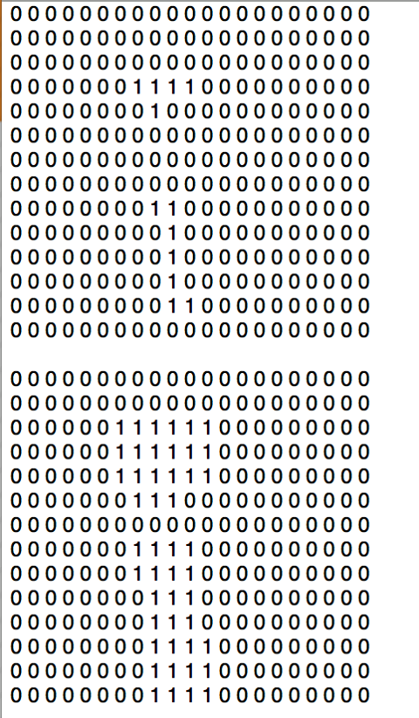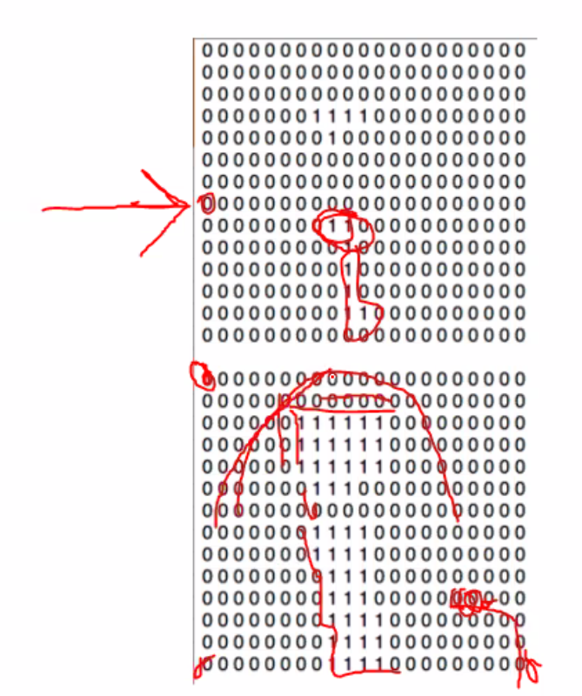

*Figure 8: Examples for adding clearance to obstacles. Left: without clearance, Right: with clearance.*

# Step 8: Full Self-Driving

Now that your car can "see", we would like to test out the vision component of your car. In particular, you will extend your obstacle course with various sorts of objects (stop signs, traffic cones, etc). You are certainly welcome to use real ones, maybe you can get small ones from a dollhouse or something, but the simplest approach might be to print out pictures of such objects and mount them on cardboard.

To construct an effective obstacle course, you'll need obstacles that look realistic enough to register in OpenCV. Here are some example graphics you can use, but you don't have to use these, feel free to get creative! Maybe you could take a picture of yourself and print yourself out and mount you as a little person on cardboard - is your car smart enough to drive around you?

|  |  |  |
| --- | --- | --- |

***Figure 9: Sample graphics you can used to test: Stop sign, traffic lights, traffic cone [24] . You can cut these out and tape them up, maybe mount them on cardboard, to make your obstacle course.***

# Part 2 Submission and Grading

Like part 1, you will create a **demo video** (under 10 mins). The video should be hosted privately on cloud, with access permission given to the course staff. **Do not upload the video to Coursera**. The demo video should contain:

1. 4 main points in the rubric.
2. The code you wrote as well as a walk through

Your final submission should be a **report** using [this template](https://docs.google.com/document/d/1ncFNOfVSrWclwlZKrlOZlfwQgiXY0LJdDH8CGVYkXw4/edit?usp=sharing)in PDF format**.** The report must contain:

1. The link for the demo video
2. Your design considerations for each steppart of the lab

| **Demo Video (70 pts)** | |
| --- | --- |
| **Advanced Mapping: Are you able to generate a map indicating obstacles? (10 pts)**  This could be a 2D binary array indicating 1’s and 0’s for obstacle and no-obstacle, or vice versa. To get more innovative you could use OpenCV to build up a map image using the binary array - something like red pixels where an obstacle is detected, green elsewhere.  A perfect submission should show the car and the obstacle(s), the car scanning its surroundings, and the map it generates in one continuous video. | |
| Students show that the car is able to scan and generate a map of the surroundings with at least one obstacle present in the periphery. | 10 |
| The map isn’t correct but the students have correct code that they can explain and pin-point possible issues. | 4 |
| **Object Detection (10 pts)** | |
| The car can correctly detect objects and students demonstrate some ideas that they tried to speed up the fps. | 10 |
| The car can detect objects but identifies them incorrectly (wrong labels) | 6 |
| Nothing works but the students show what they tried and the issues they faced | 1-3 |
| **Self-Driving Navigation (Routing) (20 pts)**  A perfect submission should satisfy the following requirements:   1. The destination is clearly marked. 2. There are at least 2 obstacle obstructing the car 3. The same recording must show the car navigating to at least 2 different destinations with different obstacle setup. This will help us verify that the routing and navigation indeed works. 4. Routing is done with A* or derivation of A* 5. The car must periodically rescan and recompute its mapping and routing as it navigates the course. | |
| The car can correctly route to destination in both runs, while avoiding the obstacles. | 20 |
| The car can correctly route to both destination but run into obstacles occasionally | 15 |
| Routing does not seem to work at all, but students show the car should be able to sense its environment and calculate the optimal path using A* by showing correct code, and can pin-point possible issues. | 0-10 |
| Routing is done without using A* or derivation of A*, or without rescans, or with obstacles oriented in a way that makes routing trivial. | 0 |
| **Full Self-Driving: Is the car able to navigate the complete route correctly along with recognizing a sign (eg. stop sign) using the camera and performing necessary maneuvers? (20 pts)**  A brief description of what a necessary maneuver means - If the car arrives at a stop sign, then the car must come to a halt. It should know that a stop sign is not an obstacle that it can maneuver around. Moreover, it is not necessary for the sign to obstruct the path of the car for it to come to a halt. Even if a stop sign is on one side of the path, the car must stop since the camera will capture the sign. This is just an example, you can have your own set of signs and traffic rules (please don’t let skipping traffic signals be one of them!)  A perfect submission should satisfy the following requirements:   1. The destination is clearly marked. 2. Students should explain what traffic sign(s) they choose to recognize and what the correct response should be. 3. Full self-driving is done with at least 1 traffic sign and 1 obstacle that clearly obstructs the car | |
| The car can correctly route to destination while avoiding at least 1 obstacle and correctly recognize and react to at least 1 traffic sign | 20 |
| The car can correctly route to destination but occasionally runs into the obstacle, or the car is slow to react to the traffic signs (perhaps due to low FPS) | 15 |
| The car can correctly route to destination, but object detection does not work. Students demonstrate that the code is correct and should work and can pin-point possible issues. | 10 |
| Routing does not work or is implemented incorrectly (eg. did not use A*), but the car can recognize the traffic sign(s) and react correctly. | 5 |
| **Code Walkthrough (10 pts)** | |
| Students clearly show and explain the code they wrote | 10 |
| Students explain the code without showing, or show the code without explaining, or show and explain only part of the code | 0-5 |
| **Report (20 pts)** | |
| **Report Comprehensiveness (20 pts)** | |
| Report contains detailed information about the students' thought process, such as how they approach the problem, how they reach their final implementation, the challenges they faced, etc. | 20 |
| Report is not comprehensive enough | 0-19 |
| **Submission Format (5 pts)** | |
| Report is submitted in PDF format, video is hosted privately on cloud with access permission granted and does not exceed the 10 minutes limit | 5 |

| **Category** | **Points** |
| --- | --- |
| Video | 70 |
| Report | 20 |
| Submission format | 5 |
| **Total** | **95** |

# Frequently Asked Questions

My ultrasonic sensor is not providing good readings, and/or my car keeps stuttering!

* Please [twist](https://en.wikipedia.org/wiki/Twisted_pair) your wires, cover them with aluminum foil, and then with electrical tape.
* Add blinders around the "eyes" of your ultrasonic sensor. Make sure your obstacles, the floor, and the wall are not reflective.
* Unplug the grayscale sensor, and build your car without it
* Tom Pawelek FA 21 discovered a [race condition](https://drive.google.com/file/d/17SEzp4-nAImAl7LT4xUvcLmuqUEZxTyc/view?usp=sharing) in the source code. To fix it, at the top of the [set_power()](https://github.com/sunfounder/picar-4wd/blob/416dfc6c381fd9f5d25d54aa785c46e8e9a27834/picar_4wd/motor.py#L17) function, add the following lines:

| self.pwm_pin.__init__(self.pwm_pin.channel) self.pwm_pin.pulse_width_percent(power) |
| --- |

* "I believe that if you jam cables together, there might be some sort of interference in signals due to electromagnetic fields product of current traveling in different directions. Because signals are unlikely to go through an error correcting protocol, like TCP/IP for example, a single disruption might change the value of a reading. In order to prevent that, I covered each set of cables (not each individual cable) with aluminum foil, and on top, covered them with electrical tape. I was trying to simulate the cover of Ethernet cables. After that, stuttering practically disappeared and readings from things like the ultrasonic came back pretty accurate, false positives went down like 95% or so. Additionally, since I have two set of cars, I changed the cable intended for the Ultrasonic with the one intended for the photo interrupted of the second car. It is a little larger and allows more room to move the US while scanning without potentially pulling the sensor due to a short cable." - Fauzi Gomez, FA 21
  + 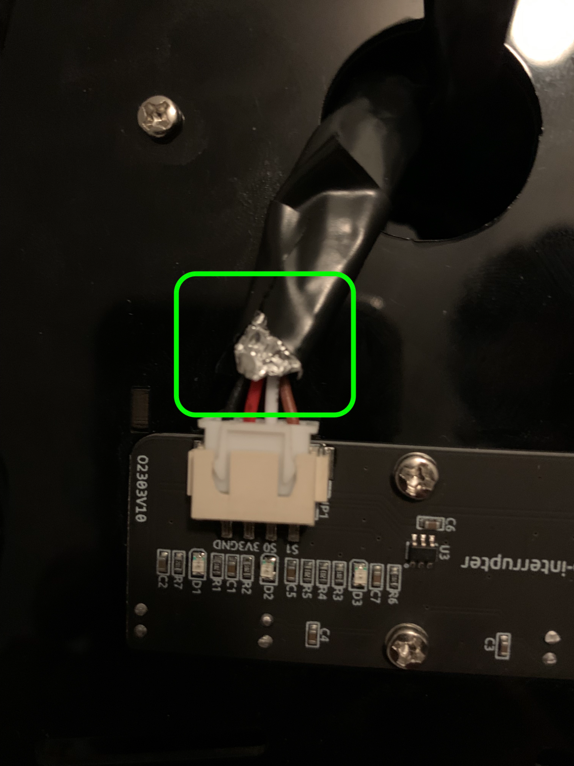

The servos/motors on my car aren't working. (thanks Christopher Fischer, Matt Williamson)

* Make sure your screws aren't too tight.
* Could be a power issue - make sure your batteries are fully charged; try changing power adapters.
* Make sure all your wires are seated firmly (connected well). For example, check to make sure the wires to the power supply are not loose.
* Try resetting your car (e.g., "picar-4wd soft-reset")

I have a motor that is going in the wrong direction.

* Try reversing polarity on the input wires
* If you use the "Speed" command/class, try taking that out.

My components arrived but something is damaged.

* Many manufacturers will ship you free replacements. Contact the manufacturer and let them know what happened.

My SD card isn't working. I'm getting a Flash failed error or some similar sort of problem.

* Try formatting your flash card again using the Raspberry Pi imager (<https://www.raspberrypi.org/software/>)
* Also see <https://forums.balena.io/t/flashing-raspberry-image-to-sd-card-always-fails/3091> or <https://www.raspberrypi.org/forums/viewtopic.php?t=196472>

My car keeps running out of power.

* While you're developing/debugging, you can power the Raspberry Pi from the USB-C, to avoid draining your batteries.
* Your batteries may have arrived damaged

I'm getting errors like ImportError and ModuleNotFoundError

* Make sure you ran the install command, eg "sudo python3 setup.py install" (and make sure you put "sudo" before that command)

I'm having trouble getting VNC working

* If you have a spare monitor, and keyboard/mouse, you can connect it to your Raspberry Pi. Many TVs have HDMI interfaces too, so you could also try connecting that if you don't have a spare monitor.

Video Length

* The video should not be more than 10 mins in length

1. If you were building a real car, having strong guarantees of timing would be critical ("brakes must close within 1ms of camera detecting pedestrian") so real cars make use of what are called Real Time Operating systems, where the programming interfaces are similar to what we will explore in this lab, but are built using schedulers that provide guarantees on the time it takes to complete various sorts of operations. Popular real time operating systems include VXWorks (used in the Mars Rover!), QNX (built by Blackberry, runs in hundreds of millions of cars!), and FreeRTOS (open source and free for commercial and noncommercial use!). Since real time operating systems are not needed for most IoT applications we'll use Raspberry Pi OS as that's a much more common platform you'll encounter in practice.
2. If you search around you'll see many other car kits online (e.g., [Link](https://www.amazon.com/dp/B07FNJ14LY/), [Alternative link](https://smile.amazon.com/SunFounder-Raspberry-Graphical-Programming-Electronic/dp/B06XWSVLL8/), [Alternative link 2](https://store.sunfounder.com/collections/robotics/products/smart-video-car?variant=35990150971553)), and even things like tanks ([Link](https://www.amazon.com/Adeept-RaspTank-Wireless-Raspberry-Transmission/dp/B07Q3RQCQS/)) and walking spiders ([Link](https://www.amazon.com/Adeept-Quadruped-Raspberry-Crawling-Self-stabilizing/dp/B07TLK5GP8/)) this lab is doable with these other platforms, but we recommend going with the SunFoundry PiCar for this lab as other platforms may have different wrapper libraries, and so you might not be able to leverage the sample code we provide. But after you do this lab you might want to go back and try some of those other platforms, for fun.
3. For more background on CAN networks see this [youtube link](https://youtu.be/FqLDpHsxvf8), or this [wikipedia page](https://en.wikipedia.org/wiki/CAN_bus).
4. If you would like to build projects that interface with your own car, this is where you plug in. Please always exercise caution when connecting with some sort of object that you care about. This video may be of assistance in locating the OBDII port in your car: <https://www.youtube.com/watch?v=dKvNft0dLBU> .
5. One thing to be careful about is to ensure you have enough electrical power. E.g., if the batteries get low, the picar lights might power up but the Pi might not have enough power to boot. Make sure the batteries always have a full charge. In fact, while you're developing, you might want to have the Pi connected to an external power source (any USB C power source 15W or higher should work).
6. One small suggestion is you may want to pause at page 45 of this manual to make sure the Pi Camera module is installed, otherwise you'll have to disassemble the hat and reinstall it, which might slow you down a bit.
7. Note you don't have to do this -- you can also use VNC to connect over SSH, as described above.
8. If these files disappear from here after reboot - don't worry, that is to be expected. See: <https://raspberrypi.stackexchange.com/questions/68808/raspberry-pi-zero-w-keeps-deleting-wpa-supplicant-conf-and-ssh-file> . You may want to make a backup of these files elsewhere in case you want to edit and make further changes on them later.
9. Or if you want something even tougher, maybe you're planning on raising the suspension and taking this thing offroad, you can drill holes to mount the camera with 4 bolts/nuts. Alternatively, you can flip the camera over and trim the plastic at the edge of the flange from the top piece of the car's frame and slide the ribbon cable through and then cut another slot to feed the ribbon up to the RPi. If you choose zip ties and you pull the zip too tight it'll aim it too far down to the ground - you can wedge something behind the camera so that the connector is flush with the mount. But none of this is really necessary,
10. If you're not so familiar with python, consider watching an online tutorial on how to run a [python interpreter](https://www.youtube.com/watch?v=jD4jRgIciHs&feature=emb_logo&ab_channel=GavenMacDonald).
11. <https://www.cnn.com/2019/10/10/tech/tesla-smart-summon/index.html>
12. If you'd like to see further, consider elevating your sensor, for example using an attachment like this: <https://www.robotshop.com/media/catalog/product/cache/image/1350x/9df78eab33525d08d6e5fb8d27136e95/w/a/waveshare-jetracer-ai-racing-robot-powered-by-jetson-nano-not-included-6.jpg> .
13. Note it would be very much in your capabilities to attempt something along these lines however - GPS units are available for sale which can be plugged into and read from your Raspberry Pi, you can download street map data from http://openstreetmap.org, and you could probably figure out how to adapt your navigation functions to routing along city streets using that information while avoiding obstacles. To go even further, you could use Openpilot (<http://comma.ai> - <https://github.com/commaai/openpilot>) to provide more comprehensive navigational capabilities, or even modify the actual car or truck you drive every day (requires specialized knowledge) with the needed robotics and sensors to make it react to inputs from your software ([https://www.youtube.com/watch?v=w8PR5wKT9VA](https://www.youtube.com/watch?v=w8PR5wKT9VA&ab_channel=TheVerge)).
14. If you think about it, there are actually a lot of tricky issues in routing. Suppose your car is about to crash into a pedestrian, but if you swerve, you'll crash into a building, hurting the driver - should your car choose to hurt you or hurt the pedestrian? Explore these ideas more here: <https://www.moralmachine.net/> .
15. For some ideas on how to think about this problem, watch this video: [https://www.youtube.com/watch?v=MUIy8s2Oo34](https://www.youtube.com/watch?v=MUIy8s2Oo34&ab_channel=ChrisJones) (also see <https://youtu.be/aXL9dbChui4>).
16. On a real autonomous car, you would extend this idea to create a "point cloud" - measuring objects' distance in a 3D band around the car.
17. Now, one issue with using 0,0 is that if you turn in certain directions it will send you into negative x,y coordinates - totally something you could handle but makes things a bit more complex as array indices can get negative. Another option would be to start the car being some distance over in the x direction and 0 in the y direction.
18. The algorithm you're implementing here is a simple SLAM algorithm - SLAM algorithms can get much more complicated, and you should definitely feel free to do something more advanced here if you would like to explore, but doing something more advanced than what we describe here is not required.
19. If you wanted to go to higher framerates, you could consider leveraging platforms like Intel Movidius or an NVIDIA Jetson Nano to offload CNN processing to hardware. This would be helpful if you were planning to drive your car around quickly, as fast reactions could help it avoid a crash.
20. Just so you are aware, as it may be useful for future projects you do, Tensorflow's website has a number of other models that can be downloaded. These models differ based both on what they are able to do (e.g., object detection, segmentation, image classification) as well as performance (e.g., quantized, floating point). For more details see [this link](https://www.tensorflow.org/lite/guide/hosted_models).
21. You certainly don't need to do this - the default Coco model should work pretty well for this lab actually. However if you want to learn more about training models you can feel free to give it a try. See this [link](https://www.tensorflow.org/lite/guide/model_maker) to learn more.
22. If you would like to have even more additional components, eg for another project, you can purchase an entire kit for example via [this link](https://www.amazon.com/dp/B07V5JTMV9/).
23. Do not worry - this video shows a fairly advanced approach, showing you the power of A* - in this lab, you will make use of a simpler variant, which will still give you some good experience with A*.
24. More graphics can be found on Pixabay (e.g., <https://pixabay.com/photos/traffic-light-signal-traffic-street-876056/>), Google image search, etc.